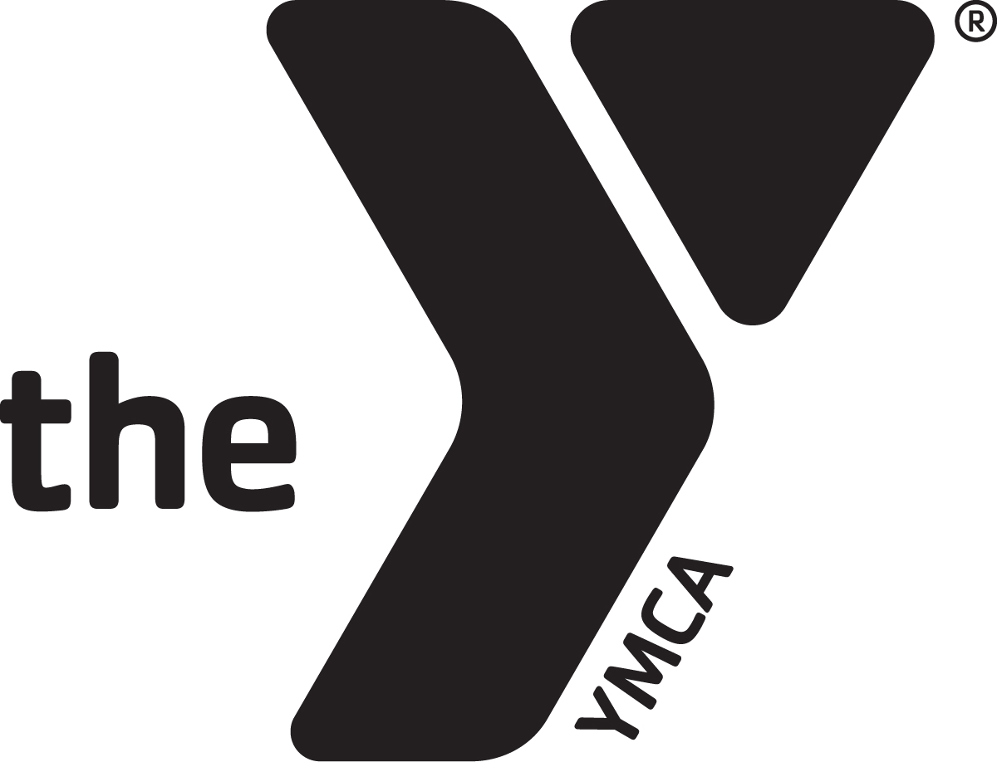 

WILSON FAMILY YMCA 3436 Airport Blvd, Wilson, NC 27896 • 252.291.9622 • wilsonymca.org

|  |  |  |  |  |  |
| --- | --- | --- | --- | --- | --- |
| Hours of Operation | | Child Watch Hours | | | FITNESS CLASS ANNOUNCEMENTS |
| Monday-Friday | 5am-8pm |  |  |  |
| Saturday | 8am-3pm |  |  |  |
| Sunday | 1pm-6pm |  |  |  |
|  |  |  |  |  |
|  |  |  |  |  |
|  |  |  |  |  |
|  |  |  |  |  |

|  |  |  |  |  |  |  |
| --- | --- | --- | --- | --- | --- | --- |
| OCTOBER 2020 CYCLING | | | | | | |
| SUN | MON | TUE | WED | THU | FRI | SAT |
| All spin classes are 45 minutes unless otherwise stated |  |  |  | 1 | 2 | 3 |
| 4 | 5  9:30 Patch  6:30pm Nancy | 6  5:45am Claire  5:15 Patch | 7  9:30 Ginny | 8  5:45am John  12:10-1:00 pm Nancy | 9  9:30 Patch | 10  8:30 am Claire |
| 11 | 12  9:30 Patch  6:30pm Nancy | 13  5:45am Claire  5:15 Patch | 14  9:30 Ginny | 15  5:45am John  12:10-1:00 pm Nancy | 16  9:30 Patch | 17  8:30 am Ginny |
| 18 | 19  9:30 Patch  6:30pm Nancy | 20  5:45am Claire  5:15 Patch | 21  9:30 Ginny | 22  5:45am John  NO 12:10-1:00 pm class | 23  9:30 Patch | 24  8:30 am Lauren |
| 25 | 26  9:30 Patch  6:30pm Nancy | 27  5:45am Claire  5:15 Patch | 28  9:30 Ginny | 29  5:45am John  12:10-1:00 pm Nancy | 30  9:30 Patch | 31  8:30 am Patch |

|  |  |  |  |  |  |  |  |  |  |  |  |
| --- | --- | --- | --- | --- | --- | --- | --- | --- | --- | --- | --- |
| OCTOBER FITNESS SCHEDULE | | | | | | | | | | | |
| SUN | | MON | | TUE | | WED | THU | FRI | | SAT | |
|  |  | |  | |  | | 1 | | 2 | | 3 |
| 4  3:00 Yoga Mary▲  5:00-5:45 Zumba-Joy▲ | 5  5:30am Powercut JohnaK+  8:30 Yoga Rebecca▲  9:30 RX Fitness Emmy▲  10:30 Low Aerobics Jessica+  10:30 Line Dance Alice▲  4:30 Line Dancing Susan+  5:45 TRX Nancy (hiit room)  6:00 Cardio Sculpt Lauren+  6:30 Yoga Judi▲ | | 6  5:45-6:45am 360 Yoga Mary  8:30 RESTORE Kim▲  9:30 Deep Stretch Emmy▲  12:10 Body Blast Nancy+  1:00 RX Fitness Mary Helen▲  6:30 Zumba Joy▲  6:30 Total Body Conditioning Nancy+ | | 7  5:30am Powercut Johna+  8:30 Powercut Ginny+  9:30 RX Fitness Emmy▲  10:30 Chair Yoga Emmy▲  5:30 Zumba Toning Joy▲  6:00 Bootcamp Tom+ | | 8  5:45-6:45am 360 Yoga Mary▲  8:30 RESTORE Kim▲  9:30 Deep Stretch Suzette  12:10 Pilates Suzette  1:00 RX Fitness Mary Helen  5:30 Yoga Stacy▲  6:00 Rope Hiit Nancy (35 min) | 9  8:30 Yoga Stacy▲  9:30 RX Fitness Emmy▲  10:30 Line Dancing Alice▲ | | 10  9:30 Total Body Conditioning Amy+  9:35-10:50 Yoga Judi▲ | | |
| 11  3:00 Yoga Judi▲  5:00-5:45 Zumba-Joy▲ | 12  5:30am Powercut JohnaK+  8:30 Yoga Rebecca▲  9:30 RX Fitness Emmy▲  10:30 Low Aerobics Jessica+  10:30 Line Dance Alice▲  12:30 Pilates Suzette▲  5:45 TRX Nancy (hiit room)  6:00 Cardio Sculpt Lauren+  6:30 Yoga Judi▲ | | 13  5:45-6:45am 360 Yoga Mary  8:30 RESTORE Kim▲  9:30 Deep Stretch Emmy▲  12:10 TRX Nancy  1:00 RX Fitness Mary Helen▲  6:30 Zumba Joy▲  6:30 Total Body Conditioning Nancy+ | | 14  5:30am Powercut Johna+  8:30 Powercut Ginny+  9:30 RX Fitness Emmy▲  10:30 Chair Yoga Emmy▲  5:30 Zumba Toning Joy▲  6:00 Bootcamp Tom+ | | 15  5:45-6:45am 360 Yoga Mary▲  8:30 RESTORE Kim▲  9:30 Deep Stretch Suzette  12:10 Pilates Suzette  1:00 RX Fitness Mary Helen  5:30 Yoga Stacy▲  6:00 Rope Hiit Nancy (35 min) | 16  8:30 Yoga Stacy▲  9:30 RX Fitness Emmy▲  10:30 Line Dancing Alice▲ | | 17  9:30 Total Body Conditioning Ginny+  9:35 Yoga Judi▲ | | |
| 18  3:00 Yoga Stacy▲  5:00-5:45 Zumba-Joy | 19  5:30am Powercut JohnaK+  8:30 Yoga Rebecca▲  9:30 RX Fitness Emmy▲  10:30 Low Aerobics Jessica+  10:30 Line Dance Alice▲  12:30 Pilates Suzette▲  4:30 Line Dancing Susan+  5:45 TRX Nancy (hiit room)  6:00 Cardio Sculpt Lauren+  6:30 Yoga Judi▲ | | 20  5:45-6:45am 360 Yoga Mary  8:30 RESTORE Kim▲  9:30 Deep Stretch Emmy▲  12:10 Body Blast Nancy+  1:00 RX Fitness Mary Helen▲  6:30 Zumba Joy▲  6:30 Total Body Conditioning Nancy+ | | 21  5:30am Powercut Johna+  8:30 Powercut Ginny+  9:30 RX Fitness Emmy▲  10:30 Chair Yoga Emmy▲  5:30 Zumba Toning Joy▲  6:00 Bootcamp Tom+ | | 22  5:45-6:45am 360 Yoga Mary▲  8:30 RESTORE Kim▲  9:30 Deep Stretch Suzette  12:10 Pilates Suzette  1:00 RX Fitness Mary Helen  5:30 Yoga Stacy▲  6:00 NO Rope Hiit | 23  8:30 Yoga Stacy▲  9:30 RX Fitness Emmy▲  10:30 Line Dancing Alice▲ | | 24  9:30 Total Body Conditioning Lauren+  9:35 Yoga Stacy▲ | | |
| 25  3:00 Yoga Mary ▲  5:00-5:45 Zumba-Joy | 26  5:30am Powercut JohnaK+  8:30 Yoga Rebecca▲  9:30 RX Fitness Emmy▲  10:30 Low Aerobics Jessica+  10:30 Line Dance Alice▲  12:30 Pilates Suzette▲  5:45 TRX Nancy (hiit room)  6:00 Cardio Sculpt Lauren+  6:30 Yoga Judi▲ | | 27  5:45-6:45am 360 Yoga Mary  8:30 RESTORE Kim▲  9:30 Deep Stretch Emmy▲  12:10 TRX Nancy  1:00 RX Fitness Mary Helen▲  6:30 Zumba Joy▲  6:30 Total Body Conditioning Nancy+ | | 28  5:30am Powercut Johna+  8:30 Powercut Ginny+  9:30 RX Fitness Emmy▲  10:30 Chair Yoga Emmy▲  5:30 Zumba Toning Joy▲  6:00 Bootcamp Tom+ | | 29  5:45-6:45am 360 Yoga Mary▲  8:30 RESTORE Kim▲  9:30 Deep Stretch Suzette  12:10 Pilates Suzette  1:00 RX Fitness Mary Helen  5:30 Yoga Stacy▲  6:00 Rope Hiit Nancy (35 min | 30  8:30 Yoga Stacy▲  9:30 RX Fitness Emmy▲  10:30 Line Dancing Alice▲ | | 31  9:30 Total Body Conditioning Nancy+  9:35 Yoga Judi▲  ▲-Gymnastics Room  +-Multi-Purpose Room  *-Robin Givens Youth Room  Please note that class times are 55 minutes unless otherwise noted. | | |